CMPG213
Analysis Document
(Phase 3)

Group 6:
50344226 – Kutloano Sabalele
50763679 – Lindokuhle Kweta
45662878 – Ruan Venter
55810608 – Reinhardt van der Walt
55807593 – Sibane Ndhlela
55985866 – Wihandré Singleton
50536192 – Zizipho Zingelwa

Client: Nkanyezi Tours

Table of Contents
1. PROJECT SCOPE 3
2. USE-CASE DIAGRAM 4
3. ENTITY-RELATIONSHIP DIAGRAM 5
4. PROCESS MODELS 6

Table of Figures
Figure 1: Use-Case Diagram 4
Figure 2: Entity Relationship Diagram 5
Figure 3: Process Diagram - Maintain Attractions 6
Figure 4: Process Diagram - Manage Itineraries 7
Figure 5: Process Diagram - Maintain Transport 8
Figure 6: Process Diagram - Maintain Accommodation 8

PROJECT SCOPE

The system must have the following functionality:
- Maintain system users and access
- Maintain attractions
- Maintain accommodation
- Maintain transport
- Manage trip expenses
- Manage itineraries
- Export data
- Generate/Request reports

USE-CASE DIAGRAM

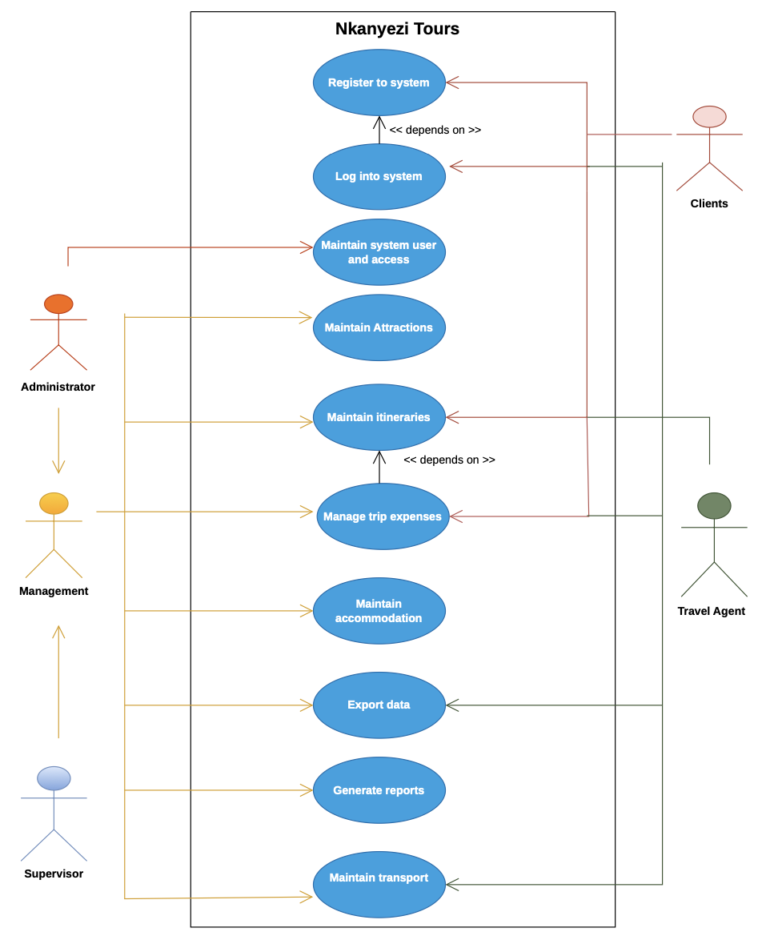
Figure 1: Use-Case Diagram

ENTITY-RELATIONSHIP DIAGRAM

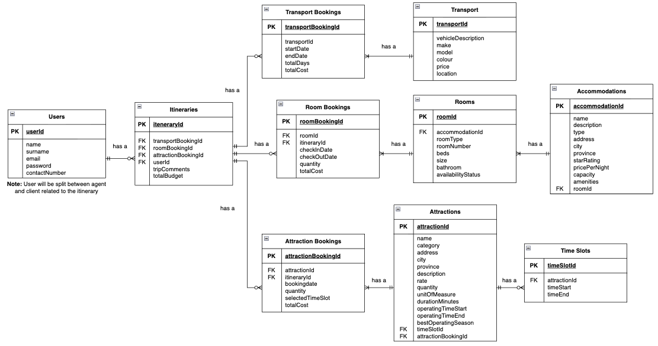
Figure 2: Entity Relationship Diagram

PROCESS MODELS

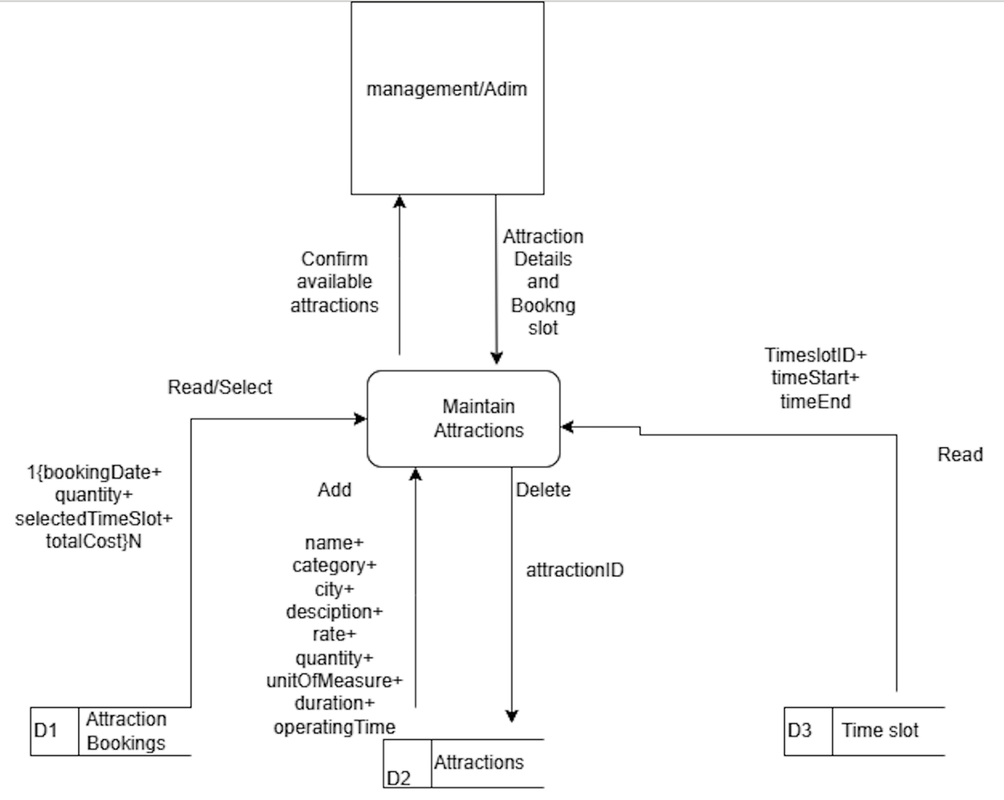
Figure 3: Process Diagram - Maintain Attractions

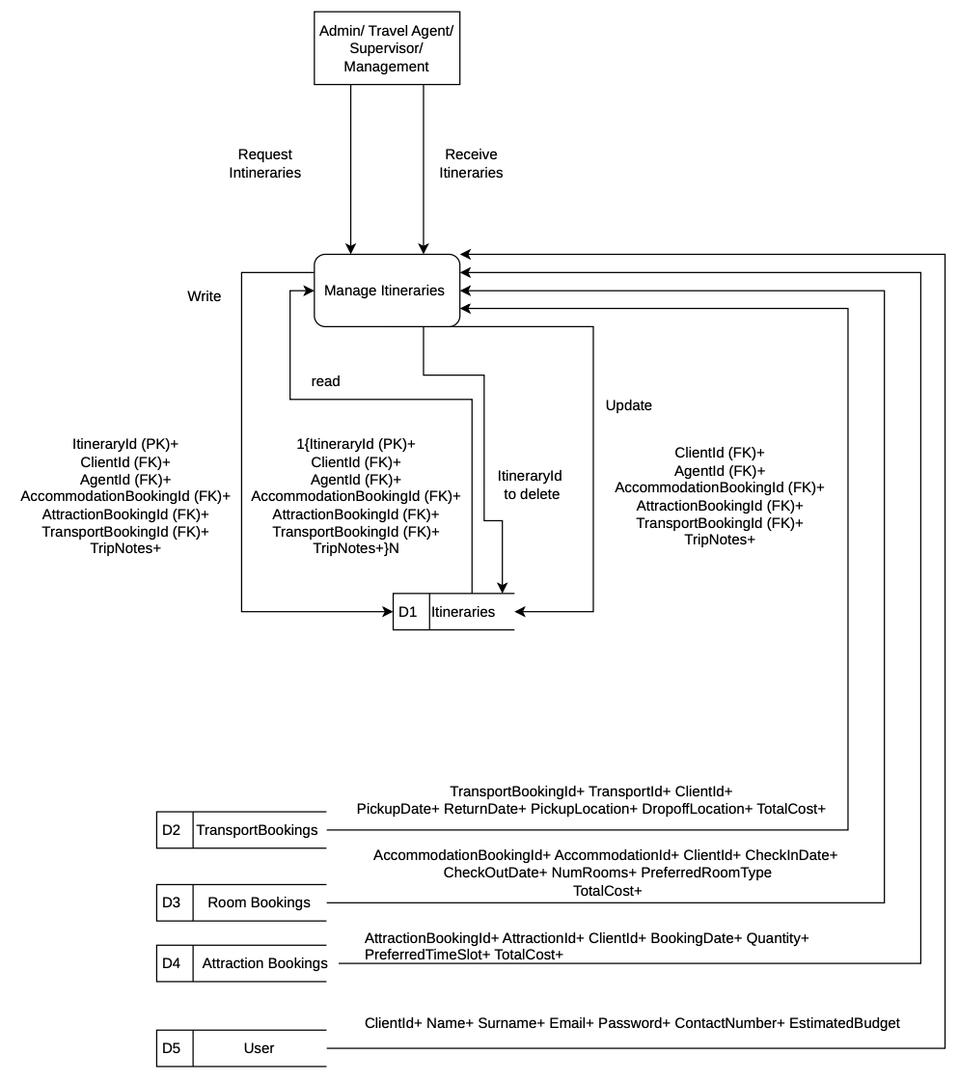
Figure 4: Process Diagram - Manage Itineraries

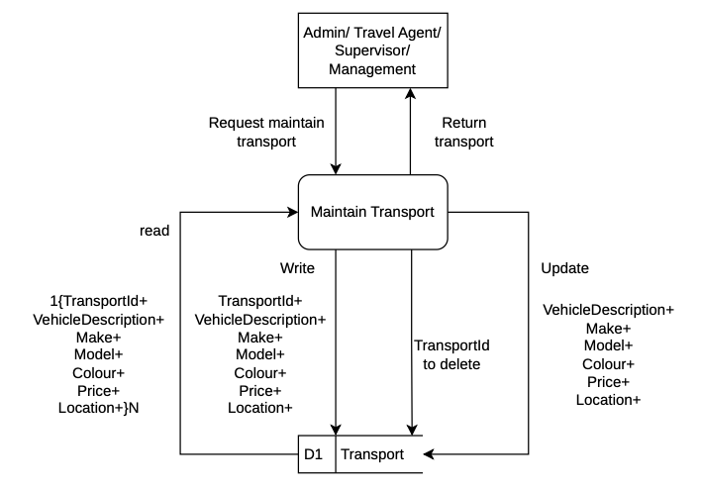
Figure 5: Process Diagram - Maintain Transport

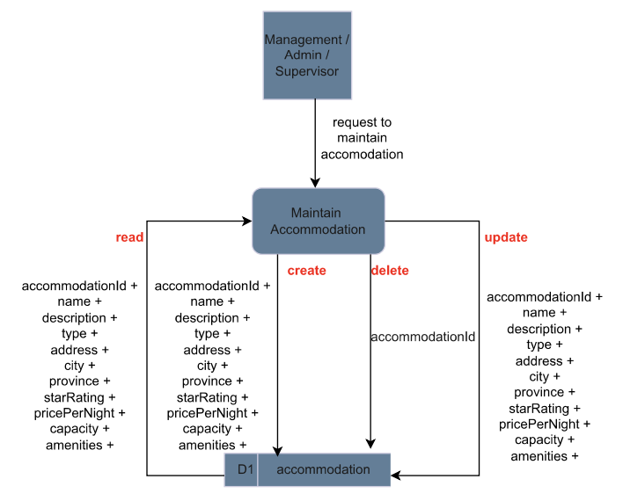
Figure 6: Process Diagram - Maintain Accommodation

